

|  |  |  |  |  |  |  |  |  |
| --- | --- | --- | --- | --- | --- | --- | --- | --- |
|  | | | | | | | | |
|  | | Final Project Report | | | | |  | |
|  |  | | | | | | |  |
|  | | | |  |  | | | |
|  | | | | STUDENT’S NAME Abdullah Tariq (088)  Rehan Malik (066)  Hamza Butt (060) |  | | | |
|  | | | | Date 19-June-2020 —Course title **Object-oriented** programming (**OOP**) —Teacher’s name **Mehak Tanveer** |  | | | |
|  | | |  | | |  | | |



|  |  |  |  |  |  |  |  |  |
| --- | --- | --- | --- | --- | --- | --- | --- | --- |
|  |  | | |  |  | | |  |
|  | Using concepts | | | | | | |  |
|  |  | | |  |  | | |  |
|  |  |  | | | |  | |  |
|  |  |  | This project is belongs to Spartans group. This is the project for banking system. Using concept of Object Oriented Programing (OOP). This project is to create and manage the Accounts of customers. Using concepts on this project are   * Class * Loop * Inheritance * Encapsulation * Operator overloading * Polymorphism * File handling(Read,Write) * Function Overloading * Pointers * Virtual functions * String stream * Constructor * Destructor * Functions * Global Variable   And many more | | |  |  |  |
|  | | | | |
|  |  |  |  |
|  |  |



|  |  |  |  |  |  |  |
| --- | --- | --- | --- | --- | --- | --- |
|  | |  |  |  |  | |
|  | | BANK MANAGEMENT SYSTEM | | |  | |
|  | |  |  |  |  | |
|  | Introduction This program is developed for managing the Banking System with the help of Server’s. In this project you can see 10 different options. These 10 options performs different operations. There are two different types of user access, customer access and admin access. There are two types of account current account and saving account.  This project is created by Spartans Group | | | | |  |

### **Classes**

We are using 4 different classes these classes are

* Login
* Account
* Current account
* Saving account

**Login:**

Login class is use to run the project without username, password you can not be able to run the program.

There are two different login access customer login access and admin login access.

**Customer access:**

Username = unknown

Password = spartans

**Admin access:**

Username = admin

Password = root

**Account:**

Account class is used to create account. Account class has two child classes.

Account class has one virtual function.

Child or drive classes are,

Current Account: is for current account

Saving Account: is for saving account

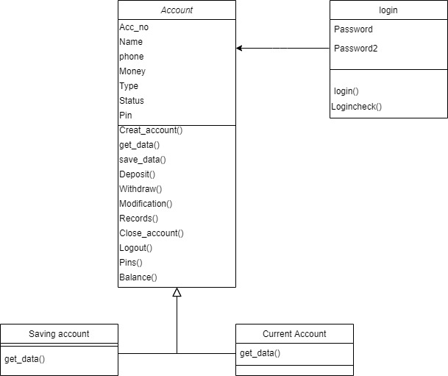

### **Features For User**

* Create Account
  + Saving account
  + Current account
* Deposit
* Withdraw
* Balance inquiry
* Modification
* Close account

### **Features For Admin**

* Create account
  + Current account
  + Saving account
* Deposit
* Withdraw
* Balance inquiry
* Modification
* Close account
* Record
  + All record
  + Saving accounts
  + Current accounts
* Pins codes
* Bank statement
* logout

### **Deposit**

Deposit menu is for add money on account.

### **Withdraw**

Withdraw menu is for cash out from account.

### **Balance Inquiry**

Balance Inquiry is for check available balance on account.

### **Modification**

Modification menu is for changing the information of account holder like (name, Phone or ATM Pin).

### **Close Account**

This menu is used to close or deactivate the account.

### **Record**

This menu is used to display the records of account. (Admin Access Required)

### **Pins**

This menu is used to display the ATM pin Codes. (Admin Access Required)

### **Bank Statement**

This menu show the details of bank available money, total customer money and bank statement that the bank is on profit or loss.

### **Logout**

Logout menu is to go back to login page and clear the access.

### **Exit**

Exit for end the program.

## Flow Chart of Project

